Will Flowers

Math 547

Jennifer Prairie

10/20/13

Matlab Assignment 1

Note: The equations of least squares I believe are wrong. I still used those numbers to do further analysis, which is also wrong, but hopefully the methods used were correct.

1. The rank of the 4X3 column is 3, which is the “m” of the nxm matrix. Therefore the column vectors are linearly independent, according with thm 3.2.8

B =

1 2 1

5 1 -1

7 4 -1

9 0 2

C =

3

1. The vectors are neither length 1 nor perpendicular to one another.

D =

12.4900

E =

4.5826

F =

2.6458

G =

35

H =

7

I =

-3

1. Q is equal to P (except for the negatives, which you said were ok)

u1 =

0.0801

0.4003

0.5604

0.7206

J =

1

v2perp =

1.7756

-0.1218

2.4295

-2.0192

u2 =

0.4897

-0.0336

0.6700

-0.5569

K =

1.0000

v3perp =

1.5724

-1.2667

-0.4695

0.8942

u3 =

0.6965

-0.5611

-0.2080

0.3961

L =

1

M =

5.5511e-17

N =

-5.5511e-17

O =

-2.2204e-16

Q =

-0.0801 0.4897 0.6965

-0.4003 -0.0336 -0.5611

-0.5604 0.6700 -0.2080

-0.7206 -0.5569 0.3961

R =

-12.4900 -2.8022 -0.5604

0 3.6259 -1.2605

0 0 2.2577

P =

0.0801 0.4897 0.6965

0.4003 -0.0336 -0.5611

0.5604 0.6700 -0.2080

0.7206 -0.5569 0.3961

1. According with thm 5.3.10, the p matrix is q\*q’, where q is the orthonormal matrix

Pmatrix =

0.7313 -0.3752 0.2281 0.0608

-0.3752 0.4762 0.3185 0.0849

0.2281 0.3185 0.8063 -0.0517

0.0608 0.0849 -0.0517 0.9862

1. T(b2) returns b2. This is because b2 is redundant with the original vectors that we used to make the orthonormal basis

b1 =

1

2

3

4

b2 =

0

3

-2

26

Tb1 =

0.9087

1.8726

3.0775

4.0207

Tb2 =

0.0000

3.0000

-2.0000

26.0000

v4 = (seconds)

0.0125

0.0250

0.0375

0.0625

0.0875

0.2625

0.2875

0.3125

0.3250

v5 = (centimeters)

17.0000

19.1000

21.2000

24.5000

27.3000

26.8000

24.6000

19.9000

17.6000

1. For the system Ax = b, x = a,b,c. A is coefficient matrix t^2, t, 1. b = height

column1 = t^2

0.0002

0.0006

0.0014

0.0039

0.0077

0.0689

0.0826

0.0977

0.1056

column2 = t

0.0125

0.0250

0.0375

0.0625

0.0875

0.2625

0.2875

0.3125

0.3250

column3 =1

1

1

1

1

1

1

1

1

1

matrixA = (column1,column2,column3)

0.0002 0.0125 1.0000

0.0006 0.0250 1.0000

0.0014 0.0375 1.0000

0.0039 0.0625 1.0000

0.0077 0.0875 1.0000

0.0689 0.2625 1.0000

0.0826 0.2875 1.0000

0.0977 0.3125 1.0000

0.1056 0.3250 1.0000

Aaug =(matrix I height)

0.0002 0.0125 1.0000 17.0000

0.0006 0.0250 1.0000 19.1000

0.0014 0.0375 1.0000 21.2000

0.0039 0.0625 1.0000 24.5000

0.0077 0.0875 1.0000 27.3000

0.0689 0.2625 1.0000 26.8000

0.0826 0.2875 1.0000 24.6000

0.0977 0.3125 1.0000 19.9000

0.1056 0.3250 1.0000 17.6000

Q = rref(Aaug)

1 0 0 0

0 1 0 0

0 0 1 0

0 0 0 1

0 0 0 0

0 0 0 0

0 0 0 0

0 0 0 0

0 0 0 0

There is no solution here because the 4th row says 0 = 1, which is impossible

1. Since there is no solution to the equation, and the vectors of A are linearly independent, we can use thm. 5.4.6 to find x\* the unique squares solution

a = -585.5

b = 201.2

c = 14.4

The least squares solution is the a b and c of the equation -1/2x^2 +bt+c, so it is a parabola.

The equation that best fits the data is: -1/2(585)t^2+201\*t+14

To find the max height we can take the derivative of the general equation to get y = –at+b. We then plug in our a and b , and solve for y = 0 to find the time of the max height ~ .344 seconds. We can plug this time in to original equation to find max height ~ 49 cm.

Graph

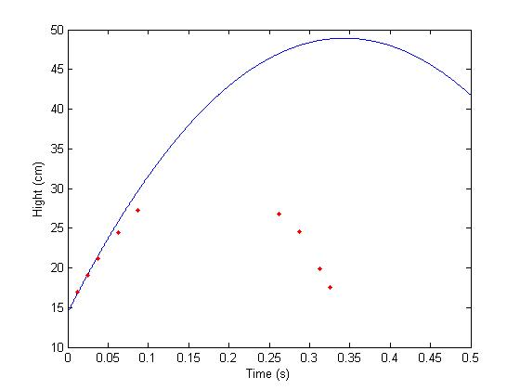

1. a and c weren’t what they should have been , thus the graph is off. This is true of the other equation/graph as well. It appears that C is quite close though in this graph (initial height), but A(acceleration due to gravity) is way off.
2. ln(y) = ln(a) +rt, after taking logs of both sides, and reducing. Also Y = exp(ln(a)+rt)

C1 = ln(a), and C2 = r

column4 =

1

1

1

1

1

1

1

column5 =

1650

1750

1850

1900

1950

1995

2005

matrixB =

1 1650

1 1750

1 1850

1 1900

1 1950

1 1995

1 2005

ystar =

1.0e+04 \*

-2.5766

0.0015

Interpretation of data:

C1 = exp(-10.3), C2 = 0.0015

A = exp(exp(-10.3)) r = 0.0015

Ln(y) = ln(exp(exp(-10.3) + 0.0015\*t

Y = exp(exp(-10.3)) + exp(0.0015\*t)

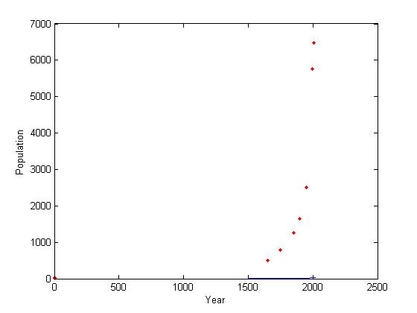

1. Graph (above). This is not a good fit either, obviously. I made an error in the calculation somewhere, was it the interpretation of numbers I got back for c1 and c2?. (Notice the solid line at the bottom between 1500 and 2000)
2. The error is lowest on the first year, and highest on the last year

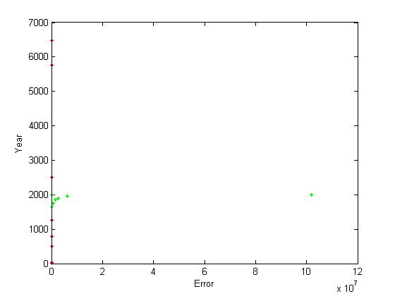

squarederror =

1.0e+08 \*

0.0025

0.0063

0.0158

0.0270

0.0611

0.0001

1.0194